*Week 2 (02/09/2020): First trial game development discussion*

*Introduction:*

For this week, my group members and I collaborated and discussed upon how to create a game. The theme had to be associated with “employability”. The task at hand was manageable but we encountered a few problems during this session. Since we were all new, we hadn’t gotten the chance to get to know one-another that well. To add to that, 3 out of the 8 members were not present but instead online. This made our communication a little sophisticated. Our lecturer gave us 40 minutes to discuss on a game, do a play-test and present our ideas to the audience on PowerPoint. Due to the complications, my team took longer than expected to come to a conclusion on a final idea. We had various different ideas, all of which were beneficial to the game. One of the problems we faced with this was time and whether we would be able to implement all of our ideas in the current time-span. In the end, simple ideas were used and others were kept in mind for future improvements and development.

*Goal and Rules:*

Our game is played on a board in which we took ideas from ‘Snakes and Ladders’ and “Monopoly”. The goal of our game is to acquire as many of the listed skills before reaching the end of the board. It is basically a race between the players/teams to see who collects the most skills along the way and being employed at the end. On the other hand, the rules we set out are as follows: Only a single type of skill card can be obtained by a player/team. Also, if you land on a ‘Lose a skill’ space, a random skill will be removed from your inventory. Finally, once a specific card is already in your hands, you may not receive the same card again even if you land on a skill card space (unless the card has been lost before)

*How the game functions:*

When the game starts, the mission would be a single job that will be available for players to attempt to get hired on. Keep in mind that every new game, a new job will be appointed with new skill cards. Players move across the board by rolling a pair of dice. When a player lands on a ‘Skill space’, they immediately gain that skill. However as mentioned before, if one lands on a ‘Lose a skill’ space, they would lose a random skill. Furthermore, same skills are spread across the board. This means that if a player lands on skill square but already has that skill, it would be neutral (the skill stays). Upon reaching the end, the players with the most skill cards in their inventory will have a higher chance of winning the game. Initially, we had planned to make it so that specific jobs will require specific skills that the players would need to acquire. But due to the lack of time, we went with a simpler idea instead. Therefore, in future developments we would program our code so that it would be a random job each time requiring players to collect specific cards to rule-out repetition in the game. An interesting feature we added was the trade option. How this works will be if both players/teams meet on the same space, they have the option to trade with one-another. Now why would players do this? Depending on the job that is being offered in the mission, different teams are required to acquire different sets of skills. One team may have a skill another team needs and vice-versa. With the trading option it allows players to be more strategic with their plays as well as it being a win-win situation.

*Figure 1: Skill cards*

|  |  |  |  |
| --- | --- | --- | --- |
| Analysis  Skill | Communication skills | Teamwork | Experience |
| Ability to learn and evolve | Passion | Excellent oral communication | Programming Skills |
| Mathematical skills | Creative problem-solving skills | Time management skills | Hygiene |

**Figure 1: An example of the skill cards that will be implemented into the game**

*Figure 2: Game’s board*

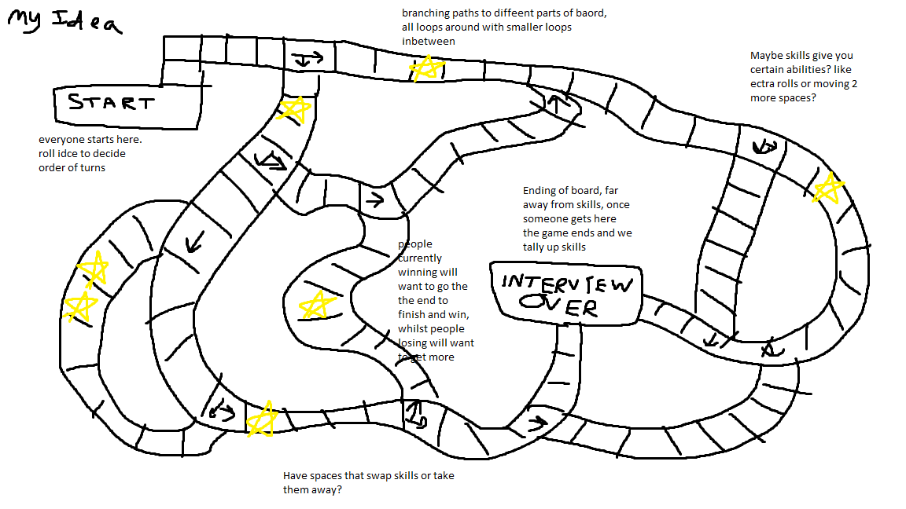

**Figure 2: A rough sketch on how the game’s board will look like**

*Play testing:*

No play-testing was carried out due to the lack of time. We will work on time-management in future discussions.